

Report 2.5.4
Recommendations to solution developers and service providers related to the digitalisation of water in irrigation.
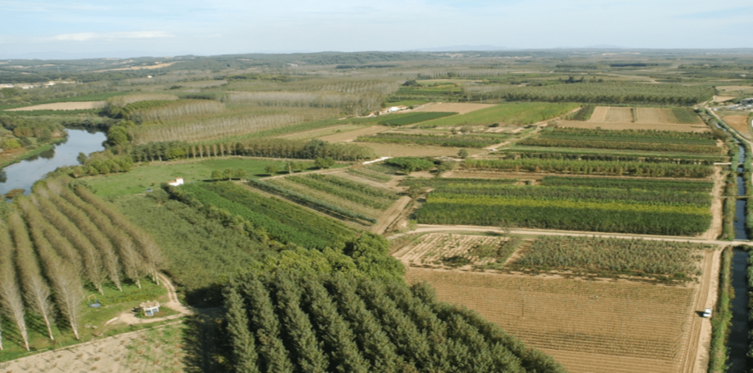

Version 2.0
March 2025

Index
Content
Index 2
Introduction. 3
2.- Digitalisation as an objective in water management. 4
3.- Optimisation of digitalisation solutions for irrigation. 5
4.- Recommendations to developers of digitalisation solutions and related service providers. 6
4.1.- Organisation of information 6
4.2.- Data management 8
4.3.- Access and permissions 9
4.4.- Costs 10
4.5.- Data flow and interoperability 12

Introduction.

The digitalisation of management processes is a reality in many areas of agricultural production. On irrigated farms, digitalisation is an indispensable tool for improving water-use efficiency, especially in water-scarce or drought-prone areas.

Two-thirds of the regulated water, in reservoirs and aquifers, used in Spain is used for agricultural production. In situations of water deficit, improving its efficiency is essential for sustainability, both economically for the agricultural sector and in terms of food for society. Therefore, the digitalisation of water management processes in irrigation communities (catchment, transport, and distribution) and the implementation of pressurised irrigation systems, along with appropriate irrigation scheduling (dosage and frequency of irrigation water), are indispensable.

Traditionally, digitalisation in the agricultural sector has been carried out by copying and adapting digitalisation processes and instruments developed in other economic sectors, which are more inclined to finance digital development. The low economic profitability of agricultural primary production hampers the development of new digital technologies among farmers, although there are compensatory mechanisms to implement digital technologies to improve the efficiency of collective water management through user and/or irrigation communities (e.g: PERTE of the digitalisation of irrigation, in Spain...) as well as through the implementation of precision irrigation instruments and technologies in plots (e.g.: CAP 2023-27. Aid to improve the competitiveness of farms in Spain; ...).

Creators or adapters of digital solutions and their adoption in the agricultural sector often know exactly what technology they are promoting but may sometimes be unaware of the motivations and decision-making idiosyncrasies in the sector.

Due to the importance of bringing two worlds closer together, the agricultural sector and the developer of digitalisation processes and tools, this document is prepared, within the framework of the Smart Green Water project, to facilitate the creation and implementation of these digital services.

2.- Digitalisation as an objective in water management.

Digitalisation enables the capture and measurement of information, which can be structured in databases and retrieved in new formats. It has two major advantages: speed of measurement and access to the information produced. Water management in a territory is always complex. Even more so when it is not an unlimited resource and is in deficit, as is often the case in Mediterranean Europe.

Therefore, the digitalisation of information on agricultural water, both its collection, transport and distribution inherent to irrigation communities, as well as its distribution in plots and application to crops in order to maximise agricultural production and the efficiency of water transformation into agricultural products in the first place and into food subsequently, is indispensable for the management of resources in the 21st century.

Although water is a public resource, private management of food and economic goods must follow efficiency criteria to avoid using more water than necessary to respect the natural water cycle. This criterion is supported by the Water Framework Directive (Directive 2000/60/EC), approved 25 years ago, and the climate prospects described by numerous organisations and climatological experts.

The modernisation of irrigation, with pressurised water for sprinkler and drip irrigation systems, has transformed irrigation and improved the efficiency of water use. The development of information and communication technologies, together with the emergence of digital sensors, represents a new technological link in agricultural water management.

The idiosyncrasies of the agricultural sector differ from those of other economic sectors, which is why the adoption of digital technologies is not the same as in other sectors. For this reason, this report, "Recommendations to solution developers and service providers related to the digitalisation of water in irrigation", has been prepared.

3.- Optimisation of digitalisation solutions for irrigation.

Broadly speaking, digitalisation solutions can have two types of users in the agricultural field, which, due to their training and capacity to handle the usual technology, determine two different types of users with different capacities and skills for interpreting the digital information to be handled:
- irrigating farmers, who are usually responsible for irrigation scheduling at the plot level.
- technical advisors, whether from irrigation communities or agricultural producer groups.
Of course, these user typologies can often be blurred and faint. But usually, we can distinguish them according to their usual environment, the field or the office, and the technological resources that they have at their disposal for most of the working day, the mobile phone or the computer, and therefore these technological resources must be the interface that interacts with each user.

Digitalisation for improving irrigation water management must bring information closer and make it understandable to all users, so they can always make the best decisions. These must be understandable and intuitive, and in each case, easy to use and adapted to the situation required.

At the same time, these digital solutions must have a cost proportional to the benefit perceived by the user, and therefore their investment and adoption of technology must be profitable. In agricultural water management, the paradox is that the most expensive water is the water that is not available. Thus, the less water is available, the more is invested in its management and efficiency. Digitalisation for decision-making is an investment that must have a good cost/benefit balance, though the greater the water scarcity, the easier the economic return on acquiring technology.

4.- Recommendations to developers of digitalisation solutions and related service providers.

Digital technologies for optimising water management in irrigation must be efficient, practical, and responsive to the concerns of users, whether farmers or technical advisors. For this purpose, it is recommended that the digital resource be presented to the user in its final part, with the users themselves. This final development enables effective adaptation to users' expectations and ensures continued use over time.

There are some bad examples of translocating digital technology for water management without considering the idiosyncrasies of the main agricultural users, and there have been failures of very accurate but difficult-to-interpret digital technology for timely decision-making. It is therefore recommended to developers of digitalisation solutions and related service providers that the final development of their solutions be carried out together with the intended users. These will assist in configuring the final interface and the appropriate digital information to facilitate more timely decision-making.
In addition, several suggestions need to be considered regarding the various aspects of implementing digital solutions, as described below.

4.1.- Organisation of information
Most certainly, the information handled by services related to the digitalisation of water in irrigation will have to be structured in a Geographic Information System (GIS). Most of the data you handle will be referenced to specific geographic coordinates, and this referencing will allow you to relate the data to one another. The different layers of information to be handled by the GIS will range from almost constant descriptive parameters, such as the elevation of the terrain, the layout of infrastructure or the boundary between plots, to descriptive parameters that change between seasons, such as the type of crop, and also variables that could be updated on a daily or even less frequent basis, such as the data on the volume of water supplied to date to a given plot.

Therefore, some GIS layers will be loaded once and updated very occasionally; others will be required on a recurring basis and will need a practical interface to do so; and others will need to be updated with calculations that will most likely be performed automatically. Finally, there may be layers of information from external sources via APIs, for example, from sensors or actuators.

In the context of GIS for irrigation digitalisation, it may be appropriate to consider different levels, each corresponding to a geographical area composed of other geometries that require individualised visualisation or management.
In terms of collective water management, it may be appropriate to consider the following levels:
- General community. Some very large communities may be formed by aggregating grassroots communities. In such cases, it may be desirable to handle both levels of aggregation and data access.
- Base community. It corresponds to the main level of collective water management. It can directly aggregate the individual plots managed by irrigators, or there can be intermediate levels of management related to infrastructure, such as sectorisation related to pipeline branches, pumping areas, hydrant clusters, etc.
- Internal sector of a community It would correspond to a level of water management that may need to be visualised or managed as its own entity.
- Individual plot. This corresponds to the level where collective management gives way to private management by the irrigator. For practical reasons, it may be desirable to match the land parcel used for compulsory crop declarations (CAP).

As far as private management by irrigators is concerned, it may be useful to distinguish the following levels:
- Private estate. This would be a collection of individual plots that share the same allocation to an irrigator (or team of irrigators). It does not necessarily correspond to a continuous geographical area, nor does it necessarily have to be contained in the same internal sector of the community, as they are different levels of organisation.
- Individual plot. It would be the same entity in which the management of irrigators coincides with that of the community.
- Management unit within a parcel. Irrigators may not manage the individual parcel homogeneously but may manage it in smaller management units. Consideration of this possibility will allow greater flexibility in adapting the level of interaction with the community and with the administration represented by the individual plot, and in accounting for the reality of management by the irrigator.

4.2.- Data management
As with any digital system used in agriculture, services related to the digitalisation of water in irrigation will need to consider certain data policy considerations.

As a reference framework for data management in digital agricultural solutions, the EU code of conduct on agricultural data sharing by contractual agreement is a document that will analyse the general principles for sharing agricultural data within the agri-food chain.

This code of conduct includes some clear considerations on access to data, which are summarised below:
- Prior to any collection, storage, or use of agricultural data, it is essential that the data originator has explicitly granted permission.
- Data may only be collected and used for the purposes specified in the contract and must only be retained for the period strictly necessary for their use.
- It will only be possible to identify the originator of the data if he has given his clear and unambiguous consent. Otherwise, it will be necessary to use pseudonyms to identify the source of the data.
- Information may only be shared with third parties if it is required for the provision of the requested service and under the conditions specified in the contract. Otherwise, only aggregated, pseudonymised or anonymised data can be shared.
- Data originators should always have appropriate and easy access to the data. In addition, there should be no limitations on moving your data to other platforms.

4.3.- Access and permissions
In the context of services related to the digitalisation of irrigation water, access to information will need to consider different user profiles. Each of these profiles may require different user interfaces. In addition, each profile will have different permissions to view or edit the data, with the particularity that these permissions may depend on the data's geographical location.

Some of the profiles to consider:
Irrigator. It would be the recipient of most of the information at the individual plot level. Therefore, an irrigator will be assigned specific plots, to which he will have access, but not to others. You will probably also want to have access to certain aggregated data including your plots. Different levels of irrigators can be identified. Firstly, according to the level of complexity of the user interfaces and the data to be accessed. For example, a distinction can be made between basic and advanced users. In addition, there could be irrigators who, in addition to being able to view information, have permission to enter or modify the data corresponding to their plots.
Collective manager. This would be the user specialised in some level of collective irrigation management. This user, instead of being assigned individual plots, is assigned a geographic area that can aggregate many plots. For example, the technician who manages irrigation requests for all plots in an irrigation community. This user will mainly handle aggregated information and information related to infrastructure. You will certainly have viewed and edited access to all the information of the area assigned to you, as well as all or part of the information of the individual parcels included.
Administrator. It may be desirable to have a user profile with full access and permissions. This includes access to personal or sensitive data. It could also be responsible for assigning access levels and permissions to other users.

4.4.- Costs
The costs of digital solutions typically include several components, as described below. The fact is that costs can vary widely depending on the business model and the niche market the digital solution is aimed at.

The physical equipment required often includes specialised components developed by the company offering the solution, as well as other components available on the market from a variety of suppliers. This would be the example of many irrigation-related sensor companies, which develop their own datalogger equipment to which they connect sensors from very specialised manufacturers. Unless it is a very innovative product, there is usually a variety of suppliers of physical equipment, so prices tend to be relatively similar across them. If customers are looking at equipment costs, it may be counterproductive to price equipment higher than competitors unless it is backed by a stronger manufacturer's reputation. In addition, equipment costs can be a significant barrier to customer entry.

Subscription to digital platforms. Physical equipment deployed in the field often reaches end users via cloud platforms, where data can be accessed. These same platforms can be complex depending on whether they only host data for access (visual or downloadable) or offer more elaborate processing, such as specialised calculations, non-trivial interpretation of observations, irrigation management recommendations, or automation. The cost of developing and operating platforms will vary according to their complexity. If we consider only the cost of development and IT maintenance of the platforms, the cost per unit of service will decrease with the number of users. For this reason, it is to be expected that generalist platforms are more affordable than specialised vertical platforms. However, the cost of operating platforms also needs to account for reliability and user engagement levels. On the one hand, depending on how critical the platform's processes are, it will require a higher level of reliability, which will increase costs. If the platform develops any kind of prescription, the level of engagement it addresses will have a huge impact on cost. If the platform assumes no responsibility, the cost overrun resulting from this commitment will be minimal; however, if the platform takes responsibility for the quality of the recommendations it provides, this cost component could skyrocket and become the main determinant of the cost of service to the user.

Customised services. Around a digital solution, which may be fully computerised, there may be different types of customised services, not automated and therefore subject to a cost per hour of staff dedication. On the one hand, this includes service contracting support, breakdown support, technical troubleshooting services, user training, etc. On the other hand, it may include consultancy services for data interpretation or process optimisation actions that can be undertaken based on the data provided by the solution.

On the other hand, a relevant aspect of the cost model is the billing unit. In digital solutions that depend on field device installation, the billing unit is usually based on the number of devices installed. For example, the price of a sensor subscription is usually related to the number of devices. On the other hand, when the service does not include a physical component that can be quantified in the field, invoicing is usually based on the number of hectares, as is common in remote sensing.

Therefore, the cost model is variable, depending not only on the integrated technology but also on strategic, rather intangible aspects, such as the level of commitment and responsibility assumed by the company that commercially exploits the solution.

4.5.- Data flow and interoperability
The data to be handled in the digitalisation of irrigation includes some layers that will only need to be updated occasionally (e.g. infrastructure layout), others that will need to be updated annually (e.g. crop distribution in the current irrigation season) and others that could be updated very frequently (e.g. irrigation requests, sensor data).

This data flow can benefit from the potential input of prebuilt datasets from other systems. Equally, the information handled by our system can be highly valuable as input to other systems. It is therefore highly desirable to make interoperability between IT systems a standard requirement in the context of the digitalisation of irrigation.

As interoperability references in the field of irrigation, the national standard UNE 318002-3 'Irrigation techniques. Remote control of irrigation areas. Part 3: Interoperability" was published in 2021 and is already being implemented in the telecontrol systems currently installed in Spain. Subsequently, at the international level, in 2024, the Standard ISO 21622-3:2024 Irrigation techniques - Remote monitoring and control for irrigation https://www.iso.org/standard/76901.htmlwas published.

The purpose of this interoperability standard is to establish the minimum data structure requirements for the transmission of data between different equipment, devices, and sensors installed in an irrigation network, regardless of manufacturer or software, enabling digital agriculture.

